All Hands Abandon Ship!
It's the same old story, really... A low-ranking officer stuck on a doomed spaceship hurtling headlong toward the inescapable gravitational pull of a quantum singularity. Only a perfect storm of systems failures stands between you and your race to find a serviceable life pod.
Good luck, Science Officer Cadet Third Class! You're going to need it.

A brief introduction to parser based game play
You’re on a doomed spaceship. To win the game, you need to find a working life pod and leave the ship before it falls into the quantum singularity.

- You interact with the game by typing commands at a prompt (think DOS or Linux.)
- You’re on a ship. To move, you can use fore, aft, port, starboard, up and down.
- Every time you enter a room, a description is printed. Many times there are hints in the description, so pay attention.
- If you miss something, type look to show the room description again.
- You can take and drop items you encounter on your way. Some items are useful, some are red herrings, and others are just for fun.
- Items you take go in your inventory.
- You can examine items to get more detail. Many times this gives clues about how an item can help you.
- Sometimes you will encounter key cards. These can be used to unlock things.
- You can unlock and open things like bulkhead doors, lockers, and access panels.
- Rooms are laid out in a regular, grid-like fashion.
- Sketching a map can help you keep yourself oriented.
- You have 100 turns to get into a life pod and launch.
- After 100 turns the life pod can no longer escape the singularity’s gravity.

But, if you fail, you don’t die. You’re simply trapped forever in the singluarity, where concepts like place and time no longer exist.
If you do happen to find yourself trapped, take the opportunity to explore the ship for your next attempt. There’s plenty to uncover.
Something interesting awaits in nearly every room, but not every room needs to be visited to win the game.
If you still need help, see one of the walkthroughs below.

Fun things to see and do while trapped inside a singularity...
- Go on an Easter egg hunt. There are references to classic films, books, games, and music scattered throughout the ship.
- Test the limits of the ship’s plumbing. Anything you can carry can be flushed down the starboard head toilet.
- Make a Mess in the Mess Kitchen. Open the freezer to find a literal red herring. Put the fish in the microwave and turn it on.
- Get a checkup. Hop up on the exam table in the Medical Exam Room and say ah.
- Have a snack. There’s a jelly donut in the Starboard Bunk and a ripe strawberry in Hydroponics and cookies in the Mess Kitchen.
- Take out the trash. Got extra stuff in your inventory? Visit the mess hall to recycle it or vaporize it in the trash bin.
- Discover Jimmy Tango’s Weight Loss Secrets. Step into the Ready Room, take the booklet and wear the taxi bead vest.
- Find a friend. Visit the Bio-Reactor room on Level A. Tap on the glass to summon a face hugger.
- Take a spacewalk. Wear the face hugger and step outside the Level A Life Pod Door. The face hugger will supply oxygen.

Hints, without too many spoilers
The ship is doomed. There's no way to fix it, so don't waste your time.
There are two life pods available for you to make your escape. Both are powered off due to a tripped breaker in Aft Engineering.
Your path to Aft Engineering is blocked by a stuck door from the aft direction and some exposed electrical wires from the forward side.
You need to overcome one of these two obstacles to access the electrical load panel and reset the breaker.
Check your inventory. Things you start with will offer clues about the areas of the ship you need to visit and in what order.
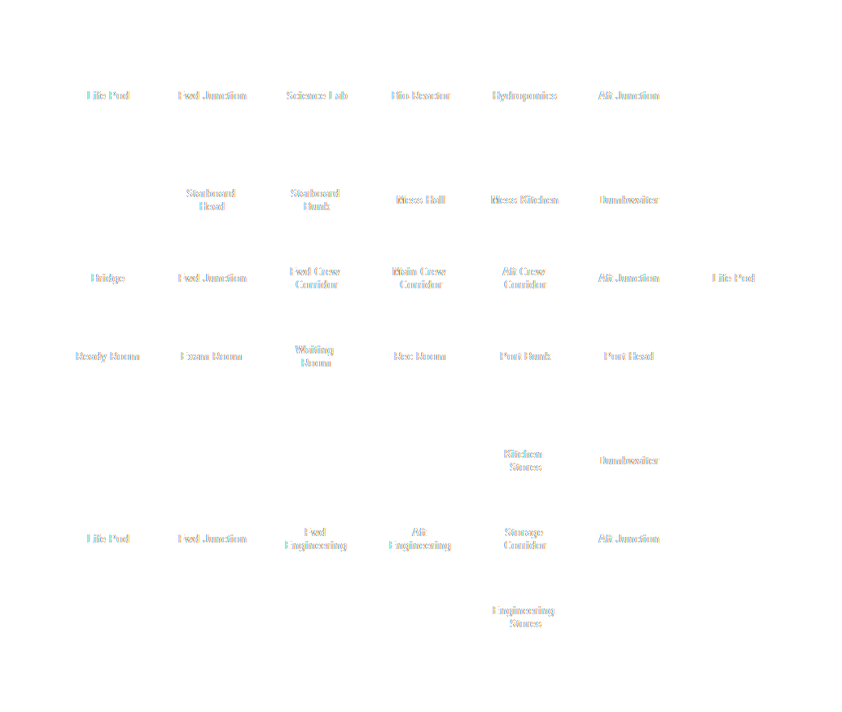
There are many things to distract you along the way. You only have 100 turns to get off the ship, but it can be done in 25.

Speed Run #1
- Get up off the toilet.
- Go aft to the Starboard Crew Bunk.
- Go port to Forward Crew Corridor.
- Go port to Medical Waiting Room.
- Go fore to the Exam Room.
- Take the Yellow Key Card from the desk.
- Go aft back to Medical Waiting Room.
- Go starboard back to Forward Crew Corridor.
- Go aft Main Crew Corridor.
- Go port to the Rec Room.
- Take the yoga mat.
- Go starboard back to the Main Crew corridor.
- Go fore to the Forward Crew Corridor.
- Go fore to the Level B Forward Junction.
- Go down to the Level C Forward Junction.
- Unlock Bulkhead C1 with the Yellow Key Card.
- Go aft to Forward Engineering.
- Drop the yoga mat to cover the exposed electrical cables.

- Go aft to Aft Engineering.
- Open the electrical load panel.
- Reset the 200A breaker.
- Go fore back to Forward Engineering.
- Go fore back to Level C Forward Junction.
- Go fore to Life Pod C.
- Get on the deceleration couch.
- Press the red launch button.

Speed Run #2
- Get up off the toilet.
- Go aft to the Starboard Crew Bunk.
- Go port to Forward Crew Corridor.
- Go aft Main Crew Corridor.
- Go starboard to the Mess Hall.
- Go aft to the Kitchen.
- Go aft to Upper Dumbwaiter Shaft.
- Go down to Lower Dumbwaiter Shaft.
- Go fore to Kitchen Stores.
- Go port to Storage Corridor.
- Go forward to Aft Engineering.
- Open the electrical load panel.
- Reset the 200A breaker.
- Go aft back to Storage Corridor.
- Go starboard to Kitchen Stores.
- Go aft back to Lower Dumbwaiter Shaft.
- Go up back to Upper Dumbwaiter Shaft.

- Go fore back to the Kitchen.
- Go fore back to the Mess Hall.
- Go port back to Main Crew Corridor.
- Go aft to Aft Crew Corridor.
- Go aft to Level B Aft Junction.
- Go aft to Life Pod B.
- Get on deceleration couch.
- Press the red launch button.

Acknowledgments
Free and open source software, public domain images, and open license fonts made this game possible.
Inform 7 – LibreOffice Writer – Trizbort – GIMP – NASA Images – Xolonium – mnicmp

Beta testers made this game playable.
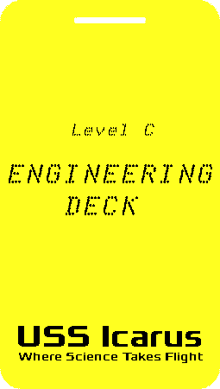
Alex H – Anne H – Jane C – Lois E – Rick B – Tom S – Val M

